Introduction to Scotland’s Ambition for Student Partnership #4

Summary Paper
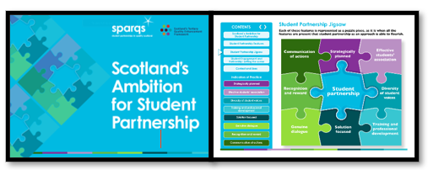

Introduction
This summary paper is intended to provide an overview of the sparqs Scotland’s Ambition for Student Partnership resource. We will also refer to it as the ‘Partnership Ambition’ within this document.

Why do I need to know about this?
The Partnership Ambition is a sector-wide reference point which underpins Scotland’s shared emphasis on a student-centred approach, and the importance of working in partnership to enhance learning and teaching practices within tertiary education. It articulates a holistic ambition for student partnership across the Scottish tertiary sector, and it describes our joint commitment to working with students and enables people to see their responsibilities and roles within this. It is a key sector reference point within Scotland’s Tertiary Quality Enhancement Framework (TQEF) which are the quality arrangements for Scottish colleges and universities. Lastly, the Partnership Ambition is a tool that provides challenge and structure to help explore ways that we can develop partnership working across Scotland.

Links with Tertiary Quality Enhancement Framework (TQEF)
The TQEF is founded on a set of six shared principles (see Fig 1) that have been used to shape its development, and which underpin and permeate every aspect of it.
These principles are Enhancement and Quality Culture; Externality; Data and evidence; Student engagement and partnership; Supporting student success and Excellence in learning, teaching and assessment. Scotland’s Ambition for Student Partnership was developed to underpin the TQEF principle of Student engagement and partnership.

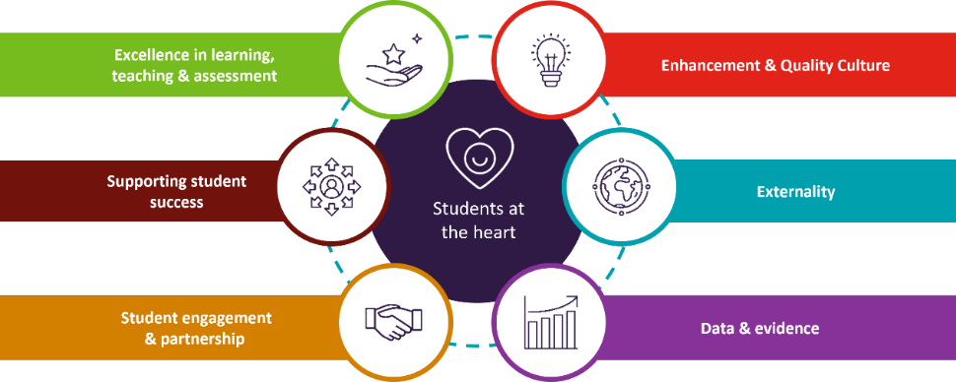
Fig 1: Principles of Scotland’s Tertiary Quality Enhancement Framework (TQEF)

At the core of these shared principles is the desire to deliver better outcomes for our students, and to place them at the heart of the framework.

What is Scotland’s Ambition for Student Partnership?
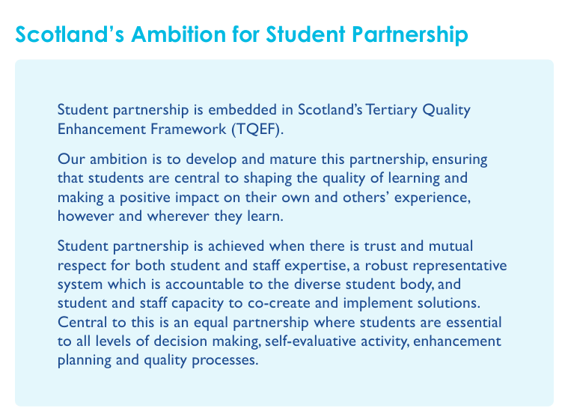

Fig 2: Ambition Statement

The Ambition Statement (Fig 2) within the Partnership Ambition is aspirational. It’s recognised that whilst there is significant good practice across Scotland, we’ll require continued enhancement activity to achieve our ambition, and this will be a journey for individual institutions and the sector as a whole. It’s about maturing what we already do (and what we’re already proud of) in Scotland, and it's about change and making a positive difference.
A fundamental aspect of the Partnership Ambition is that it’s about all students, no matter who they are, what experiences they bring with them, what barriers they might face, or where and when they study. They all have important views to bring, and if we harness these views we will meet the challenges of the future.
Trust and mutual respect are also key elements as both staff and students have expertise and we need to create an environment where we use both of these. And importantly, it’s about moving beyond just listening to students to get feedback from them, it’s about sitting down together to understand the challenges and design solutions together.
The Ambition is underpinned by both ‘Features’ and ‘Indicators of Practice’. Each of the eight features are represented as a puzzle piece in the Student Partnership Jigsaw (Fig 3), and it’s when all these features are present that student partnership as an approach is able to flourish.
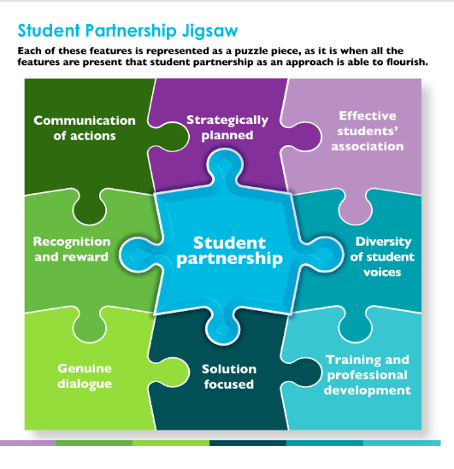
Fig 3: Features and Student Partnership Jigsaw

Each of the eight features then has indicators of practice layered beneath them, and you’ll see these in detail within the resource itself. The indicators of practice are intended to enable each feature of student partnership to be explored further. They are not designed to be a checklist, rather they are examples of practice which institutions, students’ associations and other teams can use to inform their strategic planning processes and to help them to identify their current practice and opportunities for development.

How should/could the Partnership Ambition be used?
You’ll see detailed guidance on how to use the Partnership Ambition within the resource itself. The Partnership Ambition is a sector reference point (not a checklist) and in terms of supporting institutions with the TQEF - the Ambition, Features and Indicators form a sector reference point for institutions to use when they’re asked to evidence how they work in partnership with students. This could be as part of their annual Self-Evaluation and Action Plan (SEAP) submission, or as part of the cyclical Tertiary Quality Enhancement Review (TQER) visits.
The Partnership Ambition is also intended as a practical tool for embedding partnership working across activities and processes. It can be used at institutional and programme level and possibly module or course level, and it’s a useful tool for carrying out a high-level evaluation of partnership activities. Alternatively, you might choose to use a specific feature or group of indicators that you want to explore in more detail in terms of mapping or strategic planning. The Partnership Ambition also has various other potential uses, and we’ll be capturing some of these in future case studies from a variety of Scottish tertiary institutions, so look out for those.

Role within SEAP
We've mentioned that the Partnership Ambition plays a role in supporting institutions with their annual SEAP preparation and submission. SFC’s guidance on quality for colleges and universities includes an annex dedicated to SEAP, and this outlines how the Partnership Ambition should be utilised by institutions, particularly when evaluating the TQEF principle of Student engagement and partnership.

Acronyms used
- SEAP = Self-Evaluation and Action Plan
- SFC = Scottish Funding Council
- sparqs = student partnerships in quality Scotland
- TQEF = Tertiary Quality Enhancement Framework
- TQER = Tertiary Quality Enhancement Review

You might also find our sparqs Acronym Buster helpful as you navigate terminology within the Scottish Tertiary sector.

Mapping to Professional Standards
Professional Standards for Lecturers in Scotland’s Colleges (GTCS):
1.1.2/4, 1.2.3, 1.3.2/5, 2.1.1/3/4, 2.2.1/2/3/4/5/12, 2.5.1/2/4/6, 3.2.1/2/3/4, 3.33

Professional Standards Framework 2023 (PSF 2023) (Advance HE):
V1, V2, V5, K2, K5, A1, A2, A4

Copyright

Licensed under a Creative Commons Attribution Non-commercial 4.0 licence.
You are free to copy, communicate and adapt the work, so long as you attribute sparqs.

Who are sparqs?

sparqs stands for ‘student partnerships in quality Scotland’.

We’re a Scottish sector agency and charity, with full-time staff based in Edinburgh. We work with students and staff in all institutions and students’ associations across the Scottish university and college sector, and our main funding comes from the Scottish Funding Council (SFC). You can find out more about us through our website.

Contact us

If you have questions or would like to provide feedback on this resource (or other resources within the Academic Development Toolkit) please don’t hesitate to get in touch with Prof Catriona Bell, sparqs External Consultant – catriona.bell@sparqs.ac.uk

